System and Method for Secure Session Brokering with Zero-Exposure Credential Injection in Virtual Machines

Brief Description
Existing session sharing software all utilize different approaches for achieving seamless remote access, however all conventional mechanisms such as VPN tunnels and RDP/VNC sharing, converge on having the client device hold most of the sensitive information such as authentication tokens or session keys. Attacks such as session hijacking and memory scraping remain possible as long as the client is kept privy to sensitive credential data. The attack surface is further increased as sessional artifacts often persist on disk even after the session ends. Mitigation strategies such as TLS and rotating tokens lessen the exposure but doesn’t focus on the core issue of the client device physically carrying the credentials.
Distributed Federated Access Platform (DisFAP) introduces an implemented system and method for secure session brokering while eliminating the need for client-side credential exposure. All sensitive data never exist or travel to the client device at any point, removing it from the trust boundary. The system comprises of six different layers, the first among which includes the owners and the rentees. Any person having a license to use any premium software is counted as the owner while any person who wishes to pay for using that specific software for a limited period of time is called a rentee. The owners are prompted to give away their credentials to any software which are encrypted using a HSM (Hardware Security Module RSA-4096) and stored in a Hashicorp vault, limiting its time as plaintext. This counts as the second layer. Whenever, any interested client pays for using any of the advertised software for a certain amount of time, the third layer consisting of the orchestrator is triggered. It spawns two threads, one for spooling up a virtual machine and another for retrieving credentials ensuring utmost efficiency. Layer 4 is the cloud interface for managing the virtual machines and their sessions. The penultimate layer primarily contains the Apache guacamole gateway including a custom plugin for logging in as well as its translation into safe pixels for the rentee’s browser. Finally, we get the Virtual machine which runs the licensed software and is ephemeral in nature.
Credentials are injected into the worker VM through a simple RDP/VNC handshake with Guacamole over an encrypted channel. Further, the translation to HTML5 pixel information ensures that no protocol or credential data is leaked to the client or client-side attacks. Whenever any session ends or is revoked, the VM is instantly destroyed along with the disks being wiped. As a result, the client device is reduced to just a pixel streaming platform while all the authentication and sharing logic is handled by the server-side infrastructure, allowing the architecture of this platform to enable seamless session and license sharing with zero-trust remote access.

Abstract
DisFAP (Distributed Federated Access Platform) discloses a secure session brokering system that mitigates the need for exposing credentials on the clint device by utilizing ephemeral virtual machines with server-side credential injection. License owners store their credentials in a HSM backed vault encrypted by dynamic keys. As soon as a client initiates a access request via a browser, an orchestrator is triggered which provisions a virtual machine and retrieves the required credentials concurrently. Before booting the virtual machines, authentication information is written into their disks. The Apache Guacamole gateway intercepts the RDP/VNC handshake while slipping in the credentials server-side. This is further translated into HTML5 pixel streaming information which are delivered to the client over WebSocket. At the end of any session, the virtual machine is instantly wiped clean and destroyed. This ensures that the sensitive information doesn’t come near the client network or memory.

Prior Art

Managing Credentials in a Computer System –

US 9,832,177 (Tatu Ylonen, SSH Communications OYJ, 2017)
The patent puts forward systems for managing SSH keys by securely storing them in a central repository using techniques like enforcing policies for key rotation. However, the system considers a key valid throughout its lifespan which creates a vulnerable period for misuse as the new rotated keys can’t reach all parts of the network instantly.

- Providing Forward Secrecy in a termination SSL/ TLS Connection proxy using Ephemeral Key Exchange
US 9,531,685 (Gero et al., Akamai Technologies Inc., 2016)
This patent introduces a way for ensuring forward secrecy in SSL/ TLS handshakes by using a proxy server which participates in an ephemeral Diffie Helman key exchange. Even though the proxy servers terminate keys for every new connection, they themselves are persistent, which makes them a vulnerability.

Host Virtual Machine Assisting Booting of a Fully Encrypted User Virtual Machine on a Cloud Environment

US 9,317,316 (Xinbao Lin, Huawei Tech Ltd., 2016)
This patent introduces securely booting a Virtual Machine while keeping the data encrypted by carving out a shared memory by the persistent host Virtual machine. However, the host Virtual Machine can compromise the whole system when breached.

- Integration Of Identity Access Management Infrastructure with Zero-Knowledge Services
US 20240012933 (Widmer et al., Dashlane SAS, 2024)
The patent intends to secure IAM (Identity Access Management) services by using isolated enclaves which houses decryption keys to the untrusted bulk data. However, implementing the enclave on hardware level increases reliance on specialised software which leads to vendor lock in.

Security Credential Protection With Cloud Services

US 20170317999 (Knjazihhin et al ., Cisco Technology Inc., 2017)
This patent aims to secure cloud security VMs by introducing human-approved credential release, preventing compromised systems from accessing sensitive keys. However, the additional authentication mechanisms introduce delays that can reduce scalability and automation.

Web - Based Interface Integration For Single Sign – On (SSO)

US 10,693,865 (Manza et al., Oracle International Technology, 2020)
This patent introduces a web-based SSO (Single Sign On) platform that unifies managing credentials, authentication and login flows across many different devices. The system uses a centralized proxy and a credential orchestration layer which increases the risk of a single-point-of-failure and architectural complexity.

Provisioning of Computer Systems using Virtual Machines

US 7,577,722 B1 (Khandekar et al., VMware Inc., 2009)
This patent introduces a automated Virtual Machine provisioning framework that uses templates to build, stage, clone and instantly deploy along with heuristic based resource allocation and orchestration. The sheer number of templates that will be used by a system at scale along with only a central provisioning server will make it hard to manage and slow.

Remote Provisioning of Virtual Machines

US 8,819,113 (Runcie et al., Kaseya International Ltd., 2014)
This patent introduces a remote Virtual Machine Provisioning framework where the client, inside a firewalled network, translates Virtual Machine requests from an external server into vendor specific instructions and provisions accordingly. The system depends on vendor specific translation logic which will become difficult to manage across multiple virtualization platforms.

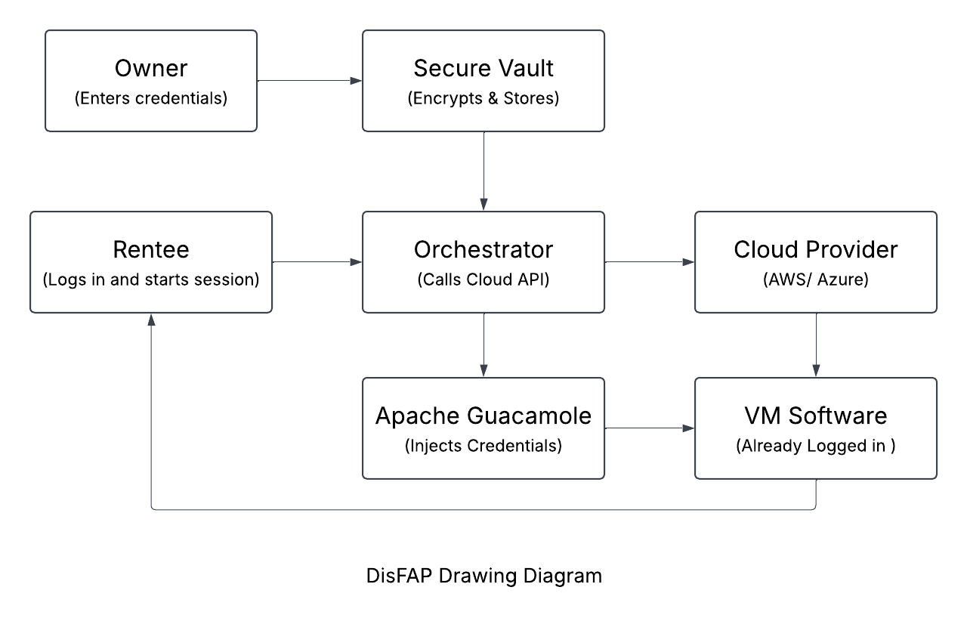

Technical Advancements
- DisFAP doesn’t allow the client device access to any of the sensitive sessional data as all the processing and session handling is carried out server side and the client side only receives the reduced pixel data.
- The architecture uses ephemeral virtual machines which are spun up on the request of rentees and destroyed as soon as their session ends. The virtual machines also simultaneously boot up and retrieve the credentials which doesn’t leave any idle window.
- Credentials are injected securely by writing them in the disk image of the virtual machines before they get booted up.
- Every owner-renter pair gets a unique encryption key built by utilizing both of their ids. This simplifies access control for specific pairs and sessions.
- As soon as the client ends or gets his session revoked, the WebSocket is closed and the virtual machine is destroyed along with its disk images.

DisFAP eliminates the need for exposing critical credential and sessional information to the client by utilizing ephemeral virtual machines, unique owner-client keys and offline credential injection which all gets wiped when the session ends.

Working Explanation
- A person who decides to rent out his credentials for any software is treated as the owner. At first, he types his credentials into our web interface which are stored in a secure vault.
- When any user decides to use any software listed to be usable, he is treated as the rentee. A unique encryption key is generated for the owner-renter pair and this key is then used for securing the credentials inside a HSM (Hardware Security Module) which is Thales Luna in our case.
- When a session is started, the rentee’s browser sends the orchestrator information about the application they want to use and who is asking. A WebSocket connection is also triggered to receive a stream of pixels.
- Once the orchestrator receives information from the rentee’s browser, it splits into two threads running simultaneously. One of the threads works on spinning up a VM with the tight permissions as well as the desired software. The other thread requests the credential vault for reading the encrypted credentials.
- Before the VM is spun up, the orchestrator gets access to the VM’s disk file directly and writes the trust certificate into the authorized logins section of the OS itself. After all this the orchestrator gives the hypervisor the signal to boot the VM.
- Meanwhile, the orchestrator deals with the vault to confirm the access permissions of the rentee and hands over the credential bundle. The orchestrator decrypts it using a private key and the plaintext data is sent directly to the Apache Guacamole gateway over a mutually verified channel which keeps the client privy to the information as it’s on a completely different network segment.
- The guacamole gateway connects to the VM using RDP/VNC. As soon as the authentication handshake is over, the credentials are slipped into the handshake itself. This is followed by guacamole wiping the credential data form its memory.
- With the VM logged in, the screen updates are given to guacamole through native protocol formats. These are translated into simple pixel commands and given to the rentee’s browser over WebSocket.

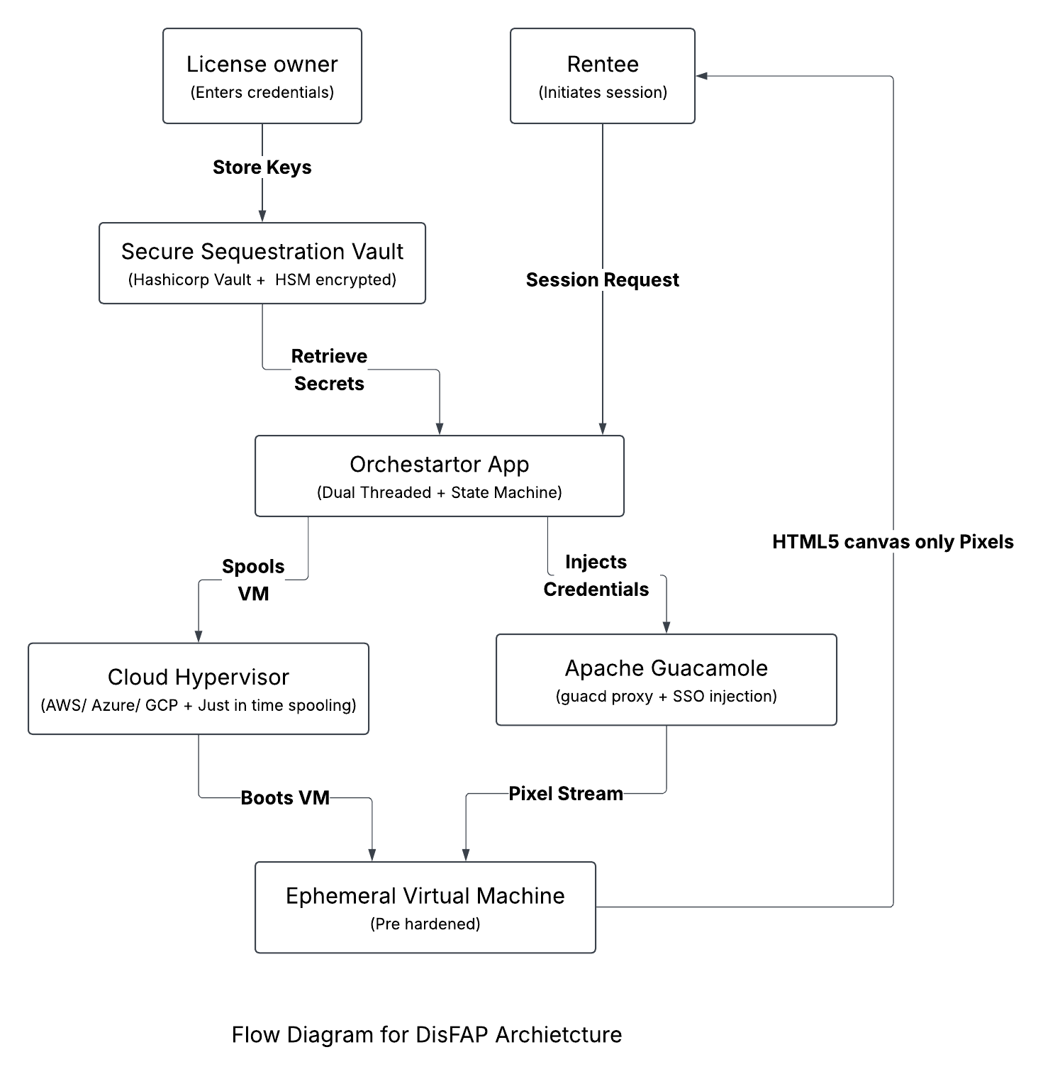
Advantages
- A person with a license of any premium expensive software (MATLAB, AutoCAD, Adobe Suite, etc.) can grant proper time-limited access to friends or students without revealing the credentials themselves which mitigate the risks of credential misuse or unauthorized distribution.
- The users only need a standard web browser with an internet connection. This low hardware requirement drastically increases the sheer number of people who can get access to such workstation-grade software.
- Whenever a rentee’s access period is over, all access is immediately lost with absolutely no chance of any lingering cached session data or credentials.
- Traditionally, offboarding involves techniques such as revoking certificates and rotating passwords, however our system terminates the rentee’s access automatically when the session ends.
- As the credentials never leave the owner’s control, the rentee can’t extract any of the installers or license keys. This keeps the license in compliance with User License Agreements.
- Applications in healthcare, finance and defense can utilize this architecture to allow external members access to applications or environments with sensitive information.
- Before the VMs are booted, the authentication artifacts are written into the disk which doesn’t leave a window during bootstrap for any attacker.
- The architecture supports any application accessible via RDP/VNC while other SSO solutions often only support web-applications only.

